**Computer Graphics PROJECT**

**Members: -**

*Sachindra Bhattacharya: 169105158*

*Rohan Puri: 169105231*

*Sanjeet Saini: 169105163*

**Introduction/Idea**

Creating a small-scale aquarium style animation. Initially, we are going to draw many fishes namely - 20 instances of the bitmap fishes as a starting step. As we progress, we’ll try to add more elements to this aquarium.

**Software/Hardware platform**

This project is done on the IDE Codeblocks, using OpenGL libraries. The code is written in C++ while including freeglut libraries. The hardware was our laptop.

**Methodology**

* Create a fish bitmap, size 32x11 {all rows must have a multiple of 8 bits}
* Fishes are assigned respective random locations and random colour
* The final display is initialized in main() and window size is defined
* The aquarium program is built and run, displaying output

**Expected outcome**

The current output of our program is given below. We hope to include more elements of an aquarium within this frame. Addition of some flora and background enhancement will be our probable next steps.

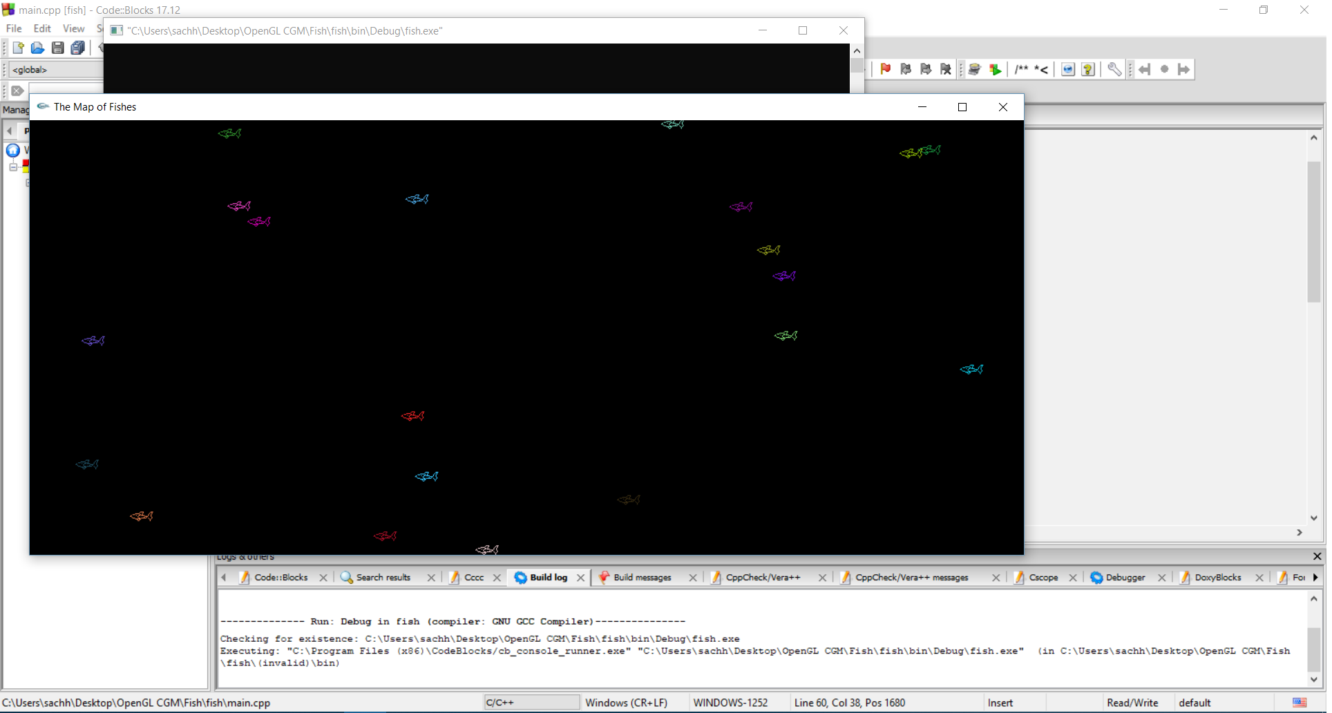

**References**

[**www.fishgl.com**](http://www.fishgl.com)

- The original source for inspiration of our project, a 3D fish Aquarium

[**https://www.youtube.com/watch?v=NPcnymtP2SE**](https://www.youtube.com/watch?v=NPcnymtP2SE)

- Thanks to Muhammad Abid for help in installing and setting up of OpenGL and GLUT libraries